Exploring Bitcoin Transactions for Rare Satoshis Using Ordinals.com
Bitcoin, as a decentralized digital currency, operates on a blockchain that records every transaction in a transparent and immutable ledger. Within this ecosystem, a satoshi, the smallest unit of Bitcoin (1 BTC = 100,000,000 satoshis), has gained attention due to its potential uniqueness and collectability, particularly rare satoshis. Using platforms like Ordinals.com, you can analyze your Bitcoin transactions to search for rare satoshis by examining transaction identifiers (TXIDs). This guide explains how to use the platform to explore sat ranges and identify rare and collectible satoshis.

Step 1: Understanding TXIDs and Their Relevance
Every Bitcoin transaction is assigned a unique identifier called a TXID. This TXID acts as a reference for all the inputs (the Bitcoin spent in the transaction) and outputs (the recipients of the Bitcoin). To check for rare satoshis, you must locate the TXID of the transaction where your Bitcoin was last sent.

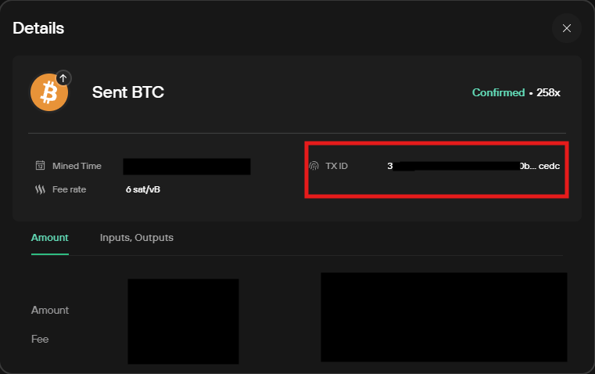

Highlighted in red is an example of where you could find a TXID in the details of a transaction using trezor.

Step 2: Accessing Ordinals.com
- Visit Ordinals.com, a platform designed for exploring Bitcoin ordinals, which are unique identifiers for satoshis.
- In the search bar, input the TXID of the Bitcoin transaction you want to analyze. This will pull up the transaction details, including all inputs and outputs associated with it.

Highlighted in red is the search bar you will use to enter the TXID to pull up the inputs and outputs.

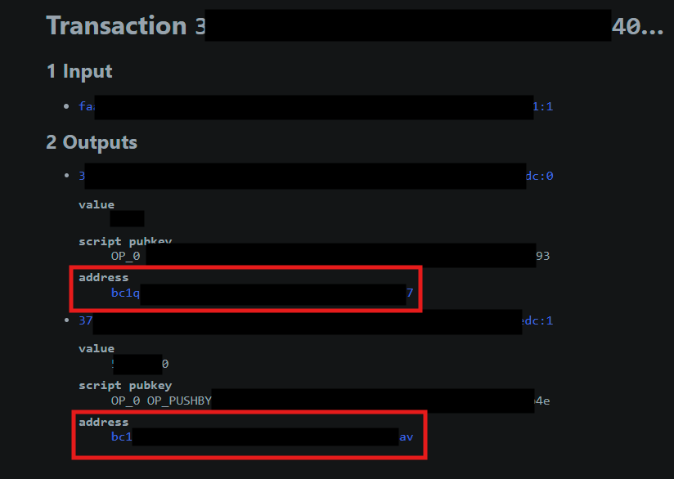

Highlighted in red are the address to search through to find the satoshis. There can be many outputs so you should go through them all.

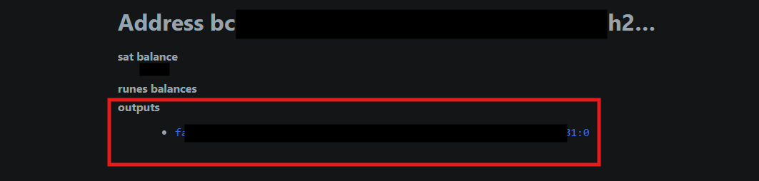

Highlighted in red is the output for the address. Click on it.

Step 3: Exploring Inputs and Outputs
- Once the TXID details are displayed, examine the outputs section. Outputs represent the Bitcoin amounts sent to different addresses during the transaction.
- Each output contains a sat range, which divides the Bitcoin into its constituent satoshis. For example, a sat range like 2256252225258530 - 2256252225260000 represents all the satoshis between these two numbers.

Step 4: Identifying Rare Satoshis
Rare satoshis are highlighted within the output details. These might include:
- First satoshis mined in a particular block.
- Satoshis from historic blocks, such as the Genesis block (Bitcoin’s very first block).
- Satoshis with unique patterns or associations, such as those mined during specific milestones.
If a satoshi within a sat range is marked as rare, it becomes collectible and can hold significant value for enthusiasts and investors.

Above is an example of a sat range containing a rare satoshi. It will be highlighted. You can click on it to view details about it.

Step 5: Interpreting Sat Ranges
Each range represents a large numerical span because Bitcoin’s total supply is divided into satoshis. For instance, the sat range 2256252225258530-2256252225260000 includes all satoshis between these two points, corresponding to how we are used to seeing Bitcoins displayed:
- Start of range: 2,256,252.25258530 BTC
- End of range: 2,256,252.25260000 BTC
By exploring these ranges, you can pinpoint the exact location of rare satoshis within your output.

